2011
Our next meeting is May 5th 2011 at 6:30, Canton Library. Pot luck dinner. Bring your own place setting and beverage.

President: William deLorraine
Vice President: Scott Sutherland
Secretary: Joanna deLorraine
Treasurer: Chris Sutherland
Field Trip Coordinators:
Bill deLorraine
Skyler Alverson
Scott Sutherland
Acting Co-Editors of Newsletter:
Bill & Joanna deLorraine
Webmaster: Glenn Simonelli

2011 Membership Dues collectible at any time but run from August 2011 to August 2012
If you do not have e-mail please let us know so we can mail you a hard copy of the newsletter.

Otherwise we strive to send all newsletters by e-mail. Make sure we are updated if your e-mail changes!

315-287-4652 or

wdellie@verizon.net

Please mail dues to: Chris Sutherland; Treasurer, 287 Cty. Rd. 29, Canton, NY 13617
Have you paid your dues? It’s important if you plan on collecting; you’ll need current Club membership and Eastern Federation insurance cards.
Please send a check for your dues to Chris so you can continue to receive newsletters and take part in club events.

Single Membership: $10.00. Family Membership: (Family members under the same roof at the same mailing address): $20.00

THE CLUB’S WEBSITE
www.stLawrencecountymineralclub.org

Minutes from the Last Meeting

Pot luck dinner was enjoyed by all. New member Francis Stunzi was introduced. New Business: Madrid Park Commission: Heard from Al Finnegan: New fees for the Community Center are $200.00 per day (Sat & Sun) if Bob Taillon signs up for us. Charge is 1/2for Friday or $100.00 for a total of $500.00. He explained that it costs them tens of thousands to run so they don’t nearly recoup monies. They will waive the Pavilion fees. Tentative pending review by the Madrid board. We need to get paperwork in ASAP along with security deposit.

EFTA Field Trips: 3 are scheduled; need to work out particulars on where to meet and exactly when so details can be published to Cindy Newman.

Bush: May 21st meet at Silver Leaf Diner. Depart at 9:00 AM

Powers’: Showtime Aug. 27th Depart Madrid Community Center 9:00 AAM

W. Pierrepont: June 18th Selleck Rd. Meet at Burger King Rt. 11 Canton; Depart 9:00 AM

Speakers for Meetings? Dino would like to speak on fluorescent minerals at our show. What time? How long? Bob Taillon is looking into how much it would cost to rent the Marine Corps Building at the show site.
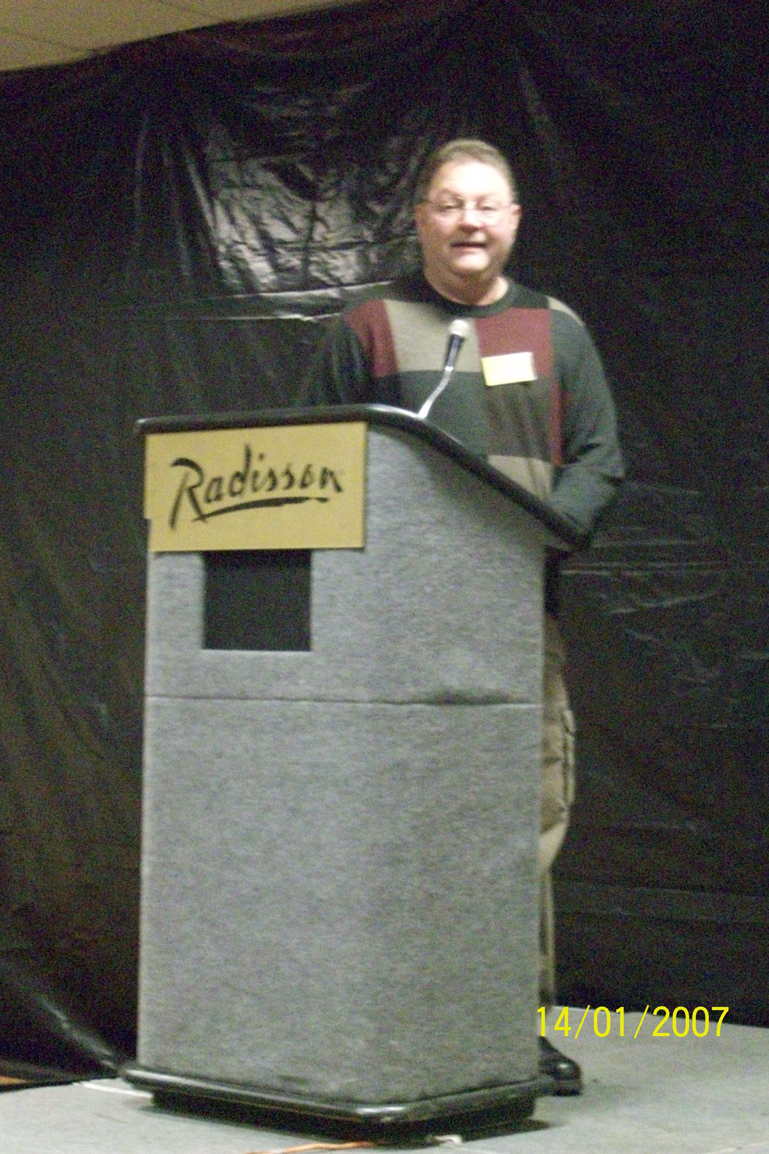

Rochester Symposium
Bill deLorraine

38th Rochester Mineralogical Symposium was held Thursday April 14th – Sunday April 17th, 2011. The Symposium is hosted by Steve Chamberlain, Chairman and Helen Chamberlain, Registrar. They were the prestigious Winners of the 2010 Carnegie Mineralogical Award and the award was showcased in the exhibit area. One of the featured speakers was our own Club President, Bill deLorraine who gave an exciting talk entitled:
“The Balmat Zinc Deposits of New York State: One of the Most Fantastic Ore Deposit Stories Ever Told”.

An open house was held at Ward’s Natural Science. Small minerals were purchased for the club’s children’s mineral kits including garnets, fluorite, pyrite, rose quartz, and quartz points.

A fantastic four day convention was held again this year. Thank You Steve and Helen!

Upcoming Shows:

June:
4th & 5th Orange County Mineral Society annual Mineral, Gem, Jewelry, Fossil Show. 10-4 Village Green Museum Village, 1010 Route 17M Monroe, NY 10950
845-683-1167

25 & 26 47th Annual Gilsum Rock Swap and Mineral Show. www.gilsum.org



July 9-10 45th Annual Show NYS Fairgrounds Center of Progress Building “Gems along the Erie Canal” Sat. 1-5 Sunday 10-4 Syracuse

24th, 15th Bancroft Gem and Mineral Show Bancroft Legion Hall Ca. 10:0-4:00

August 27-28 45th St. Lawrence County Rock and Mineral Club Annual Show;
Madrid Community Center
1835 St. Hwy. 345
Madrid, NY
Sat 9-5; Sun 9-3

September
17 & 18 Sat. 10-5, Sun. 10-4 Rhinebeck, NY Dutchess County Fairgrounds www.mhvgms.org

October
15 & 16 39th Annual Gem and Mineral Show, Bristol, CT Beals Community Ctr. www.Bristolgem.org

EFTA
Jake Kramer, editor E.F.T.A. Website: SPEEDYJAKE @aol.com

Cindy Newman knewman10@stny.rr.com

FMLS website www.amfed.org/efmls/links.htm

EFMLS/AFMS Convention

“Gems Along the Erie Canal”
Syracuse, NY
July 7-10, 2011
Gem & Mineral Society of Syracuse
Contact Cathy Patterson
315-6358-8817
315-480-8908

cathypatterson@verizon.net

The Rock Cycle
The Rock Cycle is a group of changes. Igneous rock can change into sedimentary rock or into metamorphic rock. Sedimentary rock can change into metamorphic rock or into igneous rock. Metamorphic rock can change into igneous or sedimentary rock.
Igneous rock forms when magma cools and makes crystals. Magma is a hot liquid made of melted minerals. The minerals can form crystals when they cool. Igneous rock can form underground, where the magma cools slowly. Or, igneous rock can form above

ground, where the magma cools quickly.
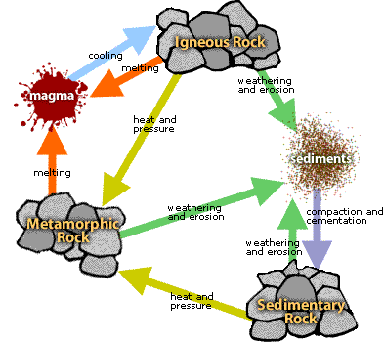
When it pours out on Earth's surface, magma is called lava. Yes, the same liquid rock matter that you see coming out of volcanoes. Water can break rock into pieces. They can also carry rock pieces to another place. Usually, the rock pieces, called sediments, drop from the wind or water to make a layer. The layer can be buried under other layers of sediments. After a long time the sediments can be cemented together to make sedimentary rock. In this way, igneous rock can become sedimentary rock.
All rock can be heated. But where does the heat come from? Inside Earth there is heat from pressure (push your hands together very hard and feel the heat). There is heat from friction (rub your hands together and feel the heat).

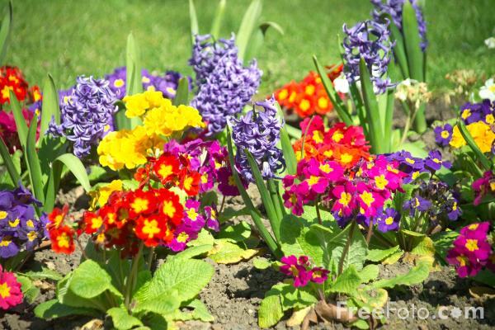
There is also heat from radioactive decay (the process that gives us nuclear power plants that make electricity).
So, what does the heat do to the rock? It bakes the rock. Baked rock does not melt, but it does change. It forms crystals. If it has crystals already, it forms larger crystals. Because this rock changes, it is called metamorphic. Remember that a caterpillar changes to become a butterfly. That change is called metamorphosis. Metamorphosis can occur in rock when they are heated to 300 to 700 degrees Celsius.

When Earth's tectonic plates move around, they produce heat. When they collide, they build mountains and may
metamorphose (met-ah-MORE-foes) the rock.
The rock cycle continues. Mountains made of metamorphic rocks can be broken up and washed away by streams. New sediments from these mountains can make new sedimentary rock.
The rock cycle never stops.
Following adapted from Scribe:
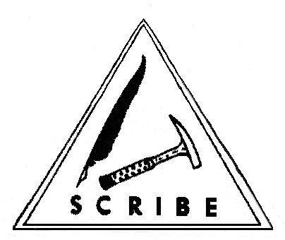

How to Plant Your Garden
No garden is without turnips:
1. Turnip for meetings
2. Turnip for service
3. Turnip to help with articles for your newsletter.

Water freely with patience and cultivate with love.
There is much fruit in your garden because you reap what you sow.

From the Internet via Calgary Lapidary Journal, 6/10
Sent in by Mike O’Toole

Birthstone for May
Emerald is the birthstone for May, and is meant to help sharpen the mind and allow healing of the body.
The beautiful, deep green of the emerald has seen it considered a precious stone since before 4000 BC. As a promoter of love and romance, it also inspires intuition and cleansing.
