Check Either: Single Membership $15.00 _______
Family Membership $25.00 _______

Print Name: ___________________________________________________ Date: ________________________

Address: ___________________________________________________________________________________

New Member? Circle: Yes No your E Mail 1: ________________________________________________

2nd adult E Mail: ________________________________________________

Is this a new email(s) registering with this club? Circle: Yes No Telephone: ( )____________________
2nd number: ( )____________________

If a Family Membership: please list names below: (All members residing at the same USPS address)

Adult # 2: ___________________________________ ______________________________________
Kids: _________________________________ ______________________________________

Monthly meetings are on the second Tuesday of each month at the Canton, NY Library, 8 Park St., downstairs in the Paige room, at 5:30 PM. We do not hold meetings in January, February, or December at the Library. The December dinner-meeting is during our annual Christmas Party; dates and place to be announced. Monthly newsletters are emailed. All field trips are listed in the monthly newsletter. Insurance cards for field trips will be sent to you via USPS mail.

Committees You might be Interested In: Are you a veteran?

Annual Show Field Trips Advertising Speakers/Programs for Meetings

Make checks payable to: “St. Lawrence Rock and Mineral Club” and return to:

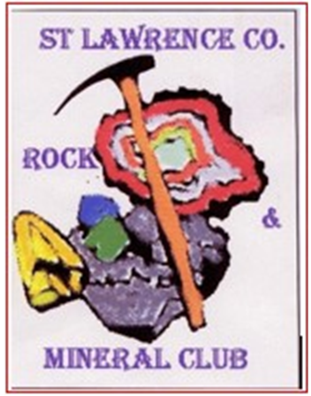
Joanna deLorraine, Secretary
St. Lawrence Rock & Mineral Club
1 Indian Head Trl, Gouverneur, NY 13642
Email: Joannadelorraine@yahoo.com

