2010
Our next meeting is October 7th at 6:30, Canton Library. Pot luck dinner. Bring your own place setting and beverage.

President: William deLorraine
Vice President: Scott Sutherland
Secretary: Joanna deLorraine
Treasurer: Chris Sutherland
Field Trip Coordinators:
Bill deLorraine
Skyler Alverson
Scott Sutherland
Acting Co-Editors of Newsletter:
Bill & Joanna deLorraine
Webmaster: Glenn Simonelli

2010 Membership Dues collectible at any time but run from August 2010 to August 2011
If you do not have e-mail please let us know so we can mail you a hard copy of the newsletter.
Otherwise we strive to send all newsletters by e-mail. Make sure we are updated if your e-mail changes!

315-287-4652 or

wdellie@verizon.net

Please mail dues to: Chris
Sutherland, Treasurer, 287 Cty. Rd. 29, Canton, NY 13617
Have you paid your dues? It’s important if you plan on collecting; you’ll need current Club membership and Eastern Federation insurance cards.
Please send a check for your dues to Chris so you can continue to receive newsletters and take part in club events.
Single Membership: $10.00. Family Membership: (Family members under the same roof at the same mailing address): $20.00
THE CLUB’S WEBSITE
www.stLawrencecountymineralclub.org.
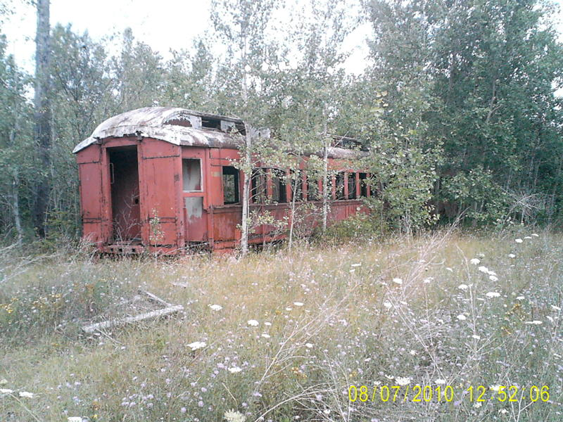
Picture taken at Benson Mines 2010

Minutes from the Last Meeting

There were 11 members in attendance. Bill asked if all had received their last newsletter. “Yes” was the response. Bill read aloud his response to a letter to the editor in the Ogdensburg Journal after the

show, concerning the drawing for the amethyst cathedral. He also read aloud another letter to the editor which was written by Fern Alverson. The club members all agreed that Bill’s response letter was good. We had a favorable review by the Madrid town officials after the show. Good feedback was received from the vendors as well. Many thanks were given to Dot Badger for her outstanding efforts on advertising again this year. We also purchased additional radio time this year plus the ad did say “come on over, rain or shine!” and it did rain, so we think that it may have helped to mention this in the radio ads. We will order more signs for next year only next time around we’ll get wire bases. Bill noted for the signs when we are gluing we need to put on hot glue and lots of it. Not “luke warm” glue. Many of the dates came off the signs. Mark Decker mentioned using calking glue or peel and stick Velcro. We only sold 45 dinners this year. May have to have the hot dog stand close sooner on Sat. and need to “talk the dinner up” at the registration table for better sales next year. Skyler mentioned he had talked with Bill Fobert who indicated that he may be interested in cooking next year. We decided to establish a Food Committee for the show next year. It will consist of team members: Skyler Alverson, Chris Sutherland, and Mark and Charlie Decker. Bill suggested
we construct a rotating wire cage for next years’ drawing. Skyler noted that Jim Gamble should be able to pick up the
amethyst cathedral for us. Sky and Fern will be going south this year to Florida and not to Deming or quartzite. Kits for kids went pretty well. We need better labels for them next year. We did not have anyone show up from the college to identify minerals this year. During the field trip no one paid Mr. Powers for the dig. Chris will send him a check for those who went and try and collect the money from them. Chris gave a report for the show. The net profit was a little down this year compared to other years, most likely because of the cost of all the new signs, lackluster sales of dinners and T-shirts. Sky mentioned we need to have the geode cracker next to the building next year, although we did sell all of the geodes where the cracker was located this year. Glen Simonelli commented that the kids were all lined up early, way before it actually got dark for the fluorescent hunt. We need to set a time of 9:30 next year. 83 kids attended. Scott asked if we should make a donation to the fire dept. We will send them a check for $50.00. Charlie made the motion and Joanna 2nd the motion. He noted the auction went well but we need to get the public more involved. Skyler noted many went out to restaurants. Bill mentioned that he had asked Dale Bush before the show if he would backhoe the collecting site at Bush Farm; the backhoeing operation proved to be a great success. Some of the best crystals in many years are now coming out. Bill paid for the backhoe and the NY State Museum reimbursed
Bill. Many clubs are going on field trips there now. Our club is going Sept. 25th and meeting at the Silver Leaf Diner for breakfast beforehand.

Upcoming Shows:

October:

2-3rd: Wayne County Gem & Mineral Club St. Michael’s School Call 315-986-4171 AmericanHobbyshop.com

17 & 18th: Johnstown Show
Johnstown Moose Lodge
Rt. 30A, Johnstown, NY
10-5 Sat. 10-4 Sunday

16-17th 38th Annual Mineral Show sponsored by the Bristol Gem & Mineral Club. Bristol Com. Center, Bristol, CT

23-24th Rochester Gem, Mineral, Jewelry and Fossil Show
West Henrietta and Calkins Rd. Henrietta, NY

November:

Nov. 6-7th
Stamford CT Mineralogical Society Gem and Mineral Show, Eastern Greenwich Civic Center
25-26: 46th Annual Atlantic
Coast Gem, Mineral and Jewelry Show hosted by the Gem Cutters Guild of Baltimore. Howard
County Fairgrounds, West Friendship, MD.

EFTA
Jake Kramer, editor E.F.T.A. website: SPEEDYJAKE @aol.com
Cindy Newman knewman10@stny.rr.com

Mineral Collecting Common Sense… Think before you act!

Marking of vugs or finds: A personal item such as, hat, shoe, paper, hammer, backpack, tools of any kind,
handkerchief, can be left on or near the find, so collector will be back for it...…..

Don’t be a claim jumper and don’t be one to claim everything you see!
Fire in the hole!
Recent incidents of people entering another person’s hole, empting it of his tools, beginning to chisel away and ruining specimens in the process, then leaving the tools strewn about, are abhorrent. It’s simply not justifiable to say “he didn’t pay his fees for the day, so it’s OK”.
I say be nice about collecting; no room for “carpetbaggers”!

