September 2010
Our next meeting is September 2nd at 6:30 Canton Library. A recap of our annual show will be the agenda. Pot luck dinner!
Bring all the yellow signs and bases back with you and we’ll put them in the storage bin at this time. We Had a Great Show!
President: William deLorraine
Vice President: Scott Sutherland
Secretary: Joanna deLorraine
Treasurer: Chris Sutherland
Field Trip Coordinators:
Bill deLorraine
Skyler Alverson
Scott Sutherland
Acting Co-Editors of Newsletter:
Bill & Joanna deLorraine
Webmaster: Glenn Simonelli

2010 Membership Dues collectible at any time but run from August 2010 to August 2011

If you do not have e-mail please let us know so we can mail you a hard copy of the newsletter.
Otherwise we strive to send all newsletters by e-mail. Make sure we are updated if your e-mail changes!

315-287-4652 or

wdellie@verizon.net

Please mail dues to: Chris Sutherland, Treasurer, 287 Cty. Rd. 29, Canton, NY 13617
Have you paid your dues? It’s important if you plan on collecting; you’ll need current Club membership and Eastern Federation insurance cards.
Please send a check for your dues to Chris so you can continue to receive newsletters and take part in club events.
Single Membership: $10.00. Family Membership: (Family members under the same roof at the same mailing address): $20.00
THE CLUB’S WEBSITE
www.stLawrencecountymineralclub.org.
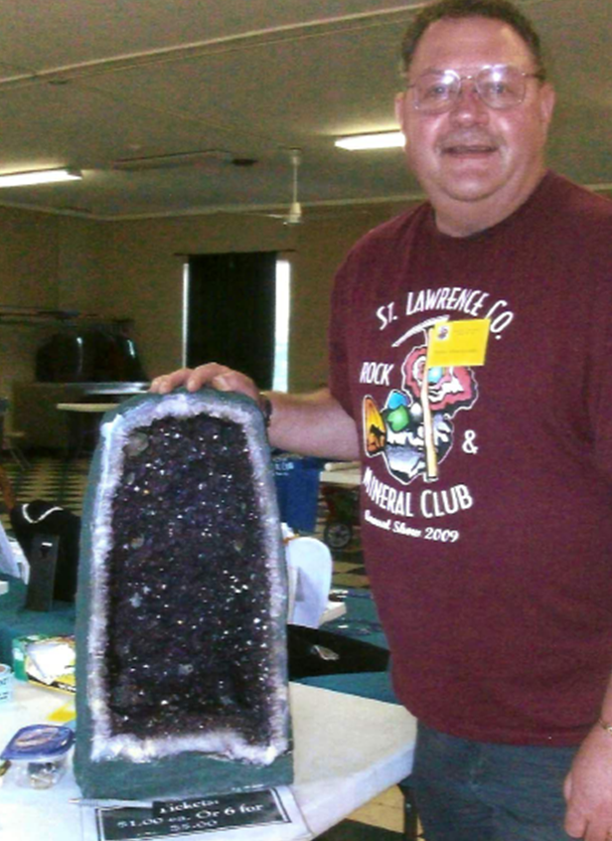
Surprised and happy winner of the 2010 Shows’ Amethyst Cathedral raffle, club President Bill deLorraine!

Minutes from the Last Meeting
A field trip is planned for Saturday the 7th to Benson Mines to collect quartz, feldspar, biotite, etc. for the children’s mineral kits for the show. We will meet in Star Lake at George Persson’s business across from the post office at 10:00. Also for the children’s kits, Bill has planned a sort trip on Friday the 6th to Harrisville to collect blue calcite and unakite. Bill will also collect drill core which has gneiss and marble for the kits. The minerals will all be in buckets that the Decker’s supplied; there will be a label for each mineral. Jerry Curcio has supplied us with a truckload of minerals for the fluorescent hunt and for the kits. Bob Taillon has supplied us with apache tears for the kits. Jerry Curcio brought a large specimen from LaFarge Quarry to be given as a door prize of dog tooth calcite on dolomite. Fern Alverson won the drawing. Bill spoke about Don Peacor coming to visit him and Joanna. He was on a collecting trip, and Bill took Don into St. Lawrence Zinc Co. Don spent the night in Gouv. to go on a collecting trip to Harrisville the following day.
Bill announced that he had received a letter from an attorney stating that a former club member had bequeathed her collection to club. Nancy Collins, who Skyler and Fern remembered. Nancy has lived in the Rochester area.
Skyler noted that he has been in touch with a band to possibly have
music on Sat. during the show.

Great job (as usual!) to Dot Badger for the excellent coverage she’s doing for our show. Bill said we will be having extra radio ad coverage the week before the show.
September:
18-19: Central Pennsylvania Rock & Mineral Show sponsored by the Central PA Rock & Mineral Club.
Zembo Shrine, Harrisburg, PA.

18-19: Rhinebeck, NY Mid Hudson Valley Gen & Mineral Society’s Show 1-845-471-1224 www.mhvgms.org

25-26 Franklin, NJ, 54th Annual Gem, Mineral & Fossil Show, Franklin School, Washington Ave. Info. Lee Lowell 973-827-6671

October:
2-3rd: Wayne County Gem & Mineral Club St. Michael’s School Call 315-986-4171 AmericanHobbyshop.com

23-24th Rochester Gem, Mineral, Jewelry and Fossil Show
West Henrietta and Calkins Rd. Henrietta, NY

November:
Nov. 6-7th
Stamford CT Mineralogical Society Gem and Mineral Show, Eastern Greenwich Civic Center

25-26: 46th Annual Atlantic
Coast Gem, Mineral and Jewelry Show hosted by the Gem Cutters Guild of Baltimore. Howard County Fairgrounds, West Friendship, MD.

EFTA
Jake Kramer, editor E.F.T.A. website: SPEEDYJAKE @aol.com
Cindy Newman knewman10@stny.rr.com

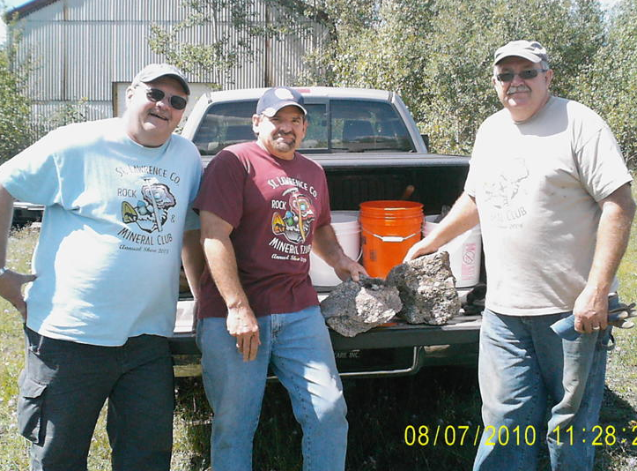

Above picture taken at Benson Mines collecting trip, Bill deLorraine, Jerry Curcio, Bob Taillon, (picture by Joanna deLorraine)

